**Tie Break1 Question**

1. Answer the questions given below using the graph below:

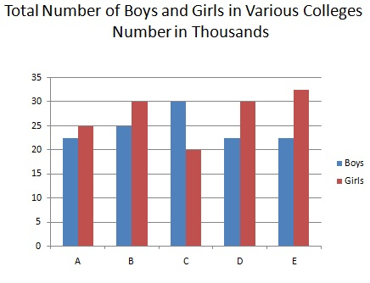

Which of the following is the average number of girls from all the colleges?

[A - 25000](javascript:void(0);)

[B - 27500](javascript:void(0);)

[C - 27000](javascript:void(0);)

[D - 25500](javascript:void(0);)

**2-The areas of two similar triangles are 81 sq. cm and 49 sq. cm. Find the ratio of their corresponding heights.**

(A) 9:7

(B) 7:9

(C) 6:5

(D) 81:49

3. Which of the following represents: ~A (negation of A) if A stands for “I like badminton but hate maths”?  
a) I hate badminton and maths  
b) I do not like badminton or maths  
c) I dislike badminton but love maths  
d) I hate badminton or like maths